# Carleton University School of Computer Science COMP 3005B

**Database Management Systems**

**Fall 2019**

**Instructor:**

[Mengchi Liu](mailto:mengchi.liu@carleton.ca)

HP 5364

**Lectures:** Tuesday and Thursday: 1:00PM - 2:25PM AT 102

**Office Hours:** Tuesday: 2:30PM - 3:30PM

**Teaching Assistants:**

1. [Adam Bennett](mailto:AdamEBennett@cmail.carleton.ca)
2. [Emma Sewell](mailto:emmasewell@cmail.carleton.ca)
3. [Mathieu Leblanc](mailto:mathieugleblanc@cmail.carleton.ca)
4. [Raghad Rowaida](mailto:raghadrowaida@cmail.carleton.ca)
5. [Yanran Guan](mailto:yanranguan@cmail.carleton.ca)

TA office hours start on September 16th.

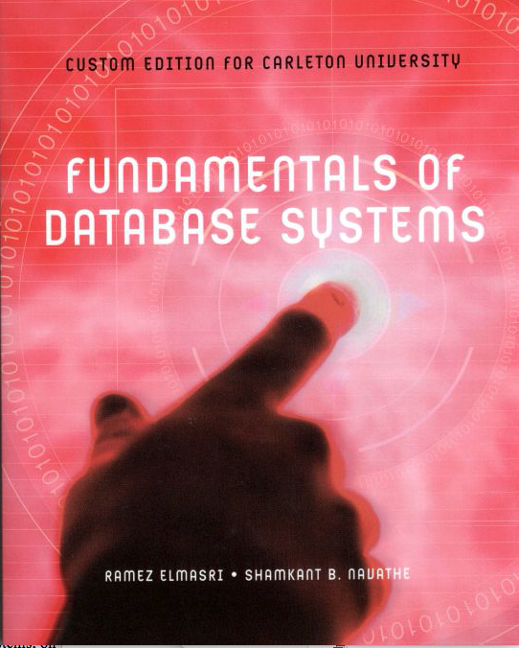**Textbook:**

1. Ramez Elmasri and Shamkant B. Navathe: **Fundamentals of Database Systems**. Seventh Edition, Pearson, 2016. Custom Edition for Carleton University (highly recommended)

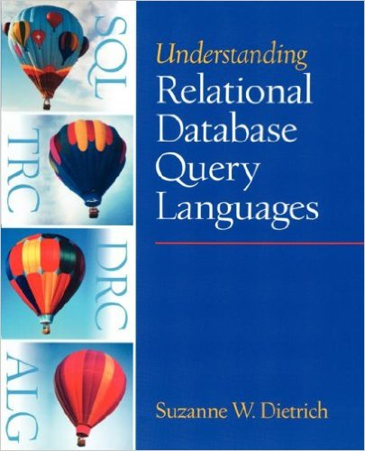

1. Suzanne W. Dietrich: Understanding Relational Query Languages. Prentice Hall, 2001 (optional)

**Prerequisites:**

COMP 1805 or MATH 1800, plus COMP 2402 or (SYSC 2004 and 2100)

**Course Information:**

We use [**culearn**](mailto:https://carleton.ca/culearn/) to host Information about the course such as announcements, lecture slides, TAs and their office hours, discussion forums, posting and submitting assignments and grading.

**Course Description:**

Introduces students to concepts of database management systems, data models, database languages, database design and physical data organization. Materials:

* Overview of Databases
* Relational Model
* Query Languages
* Relational Database Design
* ER/EER Model and Normalization
* Physical Storage Systems and Storage Structure
* Indexing
* Query Processing and Query Optimization
* Transactions and Concurrency Control
* Recovery

**Attendance**

Class attendance is important, as you will be responsible for all subjects discussed in class. No attendance will be taken, though.

**Marking Scheme:**

|  |  |
| --- | --- |
| Assignments (6) | 25% |
| Midterm (Oct. 29th in class) | 25% |
| Final (Centrally Scheduled) | 50% |

**Note：**

1. Collaborating on assignments is strictly disallowed. If found, all students involved will be given a mark of 0 and the case will be reported to the office of the Dean of Science. If you need help, please see a TA or the instructor during their office hours.
2. Posting assignment solutions on discussion boards before the due date and time is prohibited and the student involved will be given a mark of 0 for the assignment.
3. Assignments must be submitted to *culearn* in order to be marked. Assignments are allowed to be submitted one day late with 10% penalty. After one day, no submission will be accepted. Never email any assignment to me or TAs!
4. The five assignments with highest grades will count towards the 25% of the total grade for the course. However, it is important to note that assignments have different weights.
5. Any issues regarding assignment and midterm marks should be brought to the attention of the TA who marked it (only if the TA does not address the problem to your satisfaction should you bring the matter to the instructor). This should be done *no later than two weeks* after the marks of this assignment/midterm are posted. After this time, no remarking will be done.
6. Students must have *at least 45%* for the final to pass the course.

**Undergraduate Academic Advisor**

The Undergraduate Advisor for the School of Computer Science is available in Room 5302C HP, by telephone at 520-2600, ext. 4364 or by email at [*undergraduate_advisor@scs.carleton.ca*](mailto:undergraduate_advisor@scs.carleton.ca). The undergraduate advisor can assist with information about prerequisites and preclusions, course substitutions or equivalencies, understanding your academic audit and the remaining requirements for graduation. The undergraduate advisor will also refer students to appropriate resources such as the Science Student Success Centre, Learning Support Services and the Writing Tutorial Services.

**University Policies**

**Student Academic Integrity Policy.** Every student should be familiar with the Carleton University student academic integrity policy. A student found in violation of academic integrity standards may be awarded penalties which range from a reprimand to receiving a grade of F in the course or even being expelled from the program or University. Some examples of offences are: plagiarism and unauthorized co-operation or collaboration. Information on this policy may be found in the Undergraduate Calendar.

**Plagiarism.** As defined by Senate, "plagiarism is presenting, whether intentional or not, the ideas, expression of ideas or work of others as one's own". Such reported offences will be reviewed by the office of the Dean of Science.

**Unauthorized Co-operation or Collaboration.** Senate policy states that "to ensure fairness and equity in assessment of term work, students shall not co-operate or collaborate in the completion of an academic assignment, in whole or in part, when the instructor has indicated that the assignment is to be completed on an individual basis". Please refer to the course outline statement or the instructor concerning this issue.

**Academic Accommodations for Students with Disabilities.** The Paul Menton Centre for Students with Disabilities (PMC) provides services to students with Learning Disabilities (LD), psychiatric/mental health disabilities, Attention Deficit Hyperactivity Disorder (ADHD),

Autism Spectrum Disorders (ASD), chronic medical conditions, and impairments in mobility, hearing, and vision. If you have a disability requiring academic accommodations in this course, please contact PMC at

613-520-6608 or pmc@carleton.ca for a formal evaluation. If you are already registered with the PMC, contact your PMC coordinator to send me your Letter of Accommodation at the beginning of the term, and no later than two weeks before the first in-class scheduled test or exam requiring accommodation (if applicable). After requesting accommodation from PMC, meet with me to ensure accommodation arrangements are made. Please consult the PMC website for the deadline to request accommodations

for the formally-scheduled exam (if applicable) at <http://www2.carleton.ca/pmc/new-and-current-students/dates-and-deadlines>

**Religious Obligation.** Write to me with any requests for academic accommodation during the first two weeks of class, or as soon as possible after the need for accommodation is known to exist. For more details visit the Equity Services website: <http://www2.carleton.ca/equity/>

**Pregnancy Obligation.** Write to me with any requests for academic accommodation during the first two weeks of class, or as soon as possible after the need for accommodation is known to exist. For more details visit the Equity Services website: <http://www2.carleton.ca/equity/>

**Medical Certificate.** The following is a link to the official medical certificate accepted by Carleton University for the deferral of final examinations or assignments in undergraduate courses. To access the form, please go to <http://www.carleton.ca/registrar/form>